Note on Sample Design and Estimation Procedure

1.0 Objective of the survey: There are primarily two objectives of PLFS. The first is to measure the dynamics in labour force participation and employment status in the short time interval of three months for the urban areas only in the Current Weekly Status (CWS). Thus, in every quarter, PLFS will bring out the level and change estimates of the key labour force indicators in CWS viz. Worker Population Ratio (WPR), Labour Force Participation Rate (LFPR), Unemployment Rate (UR). Secondly, for both rural and urban areas, level estimates of all important parameters in both usual status and CWS will be brought out annually.

  - Outline of the Survey Programme

    - Geographical coverage of the survey: The survey covers the whole of the Indian Union except the villages in Andaman and Nicobar Islands which remain extremely difficult to access throughout the year.

1.2 Schedules of enquiry: Following schedules are canvassed:

Schedule 0.0PL | : | List of households
Schedule 10.4 | : | Employment and Unemployment (First Visit)
Schedule 10.4 | : | Employment and Unemployment (Revisit)

1.3 Sample Design
1.3.1 Rotational scheme for pilot survey:

A rotational panel sampling design has been used in urban areas. The rotational scheme is of two years duration to accommodate the changes in the urban frame in the intracensal period; in the sense that the sampling frames for both rural and urban areas will remain unchanged for every two-year duration. In this rotational panel scheme each selected household in urban areas will be visited four times – one with first visit schedule and other three with revisit schedule. The estimates can be given for successive quarters without any break in the series (starting from the fifth quarter), ensuring a 75% matching between consecutive quarters. The proposed design aims at generating quarterly estimates of level and change parameters of some important labour force indicators (LFPR, WPR & UR) based on CWS data in urban areas and annual estimates of level parameters based on usual status for both rural and urban areas in the line of employment & unemployment survey of NSS quinquennial round.

1.3.2 Rotational panel design for urban areas
  - The initial rotational panel is for two years, where only 25% FSUs of urban annual allocation will be covered in the first quarter (Panel P₁₁) with detail listing and canvassing of visit 1 schedule in the selected households; where P_{ij} indicates the panel belonging to j^{th} quarter of the i^{th} two-year period of rotation.
  - Another 25% FSUs will be covered in the second quarter (Panel P₁₂) for taking up visit 1 schedule and revisit schedule will be canvassed in the selected households of Panel P₁₁.
  - A new panel P₁₃ of 25% FSUs will be surveyed in third quarter with visit 1 schedule and revisit schedules will be canvassed in the households of panels P₁₁ & P₁₂.
  - In the fourth quarter, households of panels P₁₁, P₁₂ & P₁₃ will be surveyed with revisit schedule and a new panel P₁₄ with 25% FSUs for visit 1 schedule.
  - In the subsequent quarters of second year 75% FSUs (3 panels - P₁₂, P₁₃ & P₁₄) will be common and an earlier panel (P₁₁) will be replaced by a new panel (P₁₅) for canvassing visit 1 schedule. This will continue till 8th quarter.
  - All the FSUs of the panels P₁₁, P₁₂, ...., P₁₈ (each of which is with 25% of FSUs) will be selected before commencement of survey in the first quarter.
  - At the end of the second year of each two-year duration, updated frame will be used for both rural and urban areas.
  - FSUs of another set of panels P₂₁, P₂₂, ..., P₂₈ selected from the updated frame will be made ready before commencement of first quarter of third year (first quarter of the second two-year duration). These panels P₂₁ to P₂₈ will take care of the changes in the urban frame during the intracensal period.
  - In the ninth quarter (first quarter of the second two-year duration), panel P₂₁ selected from the updated frame will be introduced and the panels P₁₆, P₁₇ and P₁₈ of the old frame will be surveyed.
  - This scheme will continue for another 2 years with the introduction of panels P₂₂ to P₂₈ each in one quarter for the subsequent 7 quarters till the end of the fourth year (second year of the two-year period).
  - This scheme of rotation of panels will enable generation of estimates of change parameters with 75% matching and 25% of unmatched samples from fifth quarter onwards.
  - One of the main advantages of this plan of rotation is that there will not be any break in the series of estimates of the change parameters starting from 5th quarter.
  - Since major changes in the rural-urban frame occurs in the Census years (say for the year 2023-24), provision is to be made to generate estimates without break in the series of estimates considering panels from pre and post-census frames.

1.3.3 Rural samples

For rural areas, samples for all the 8 quarters have been selected before commencement of survey for each two-year period, while the frame remains same for this duration. In each quarter, only 25% FSUs of annual allocation (as is done in each sub-round of NSS rounds) are being covered in rural areas so that independent estimates can be generated for each quarter. For this purpose, quarterly allocation is multiple of 2 for drawing interpenetrating sub-samples.

There will not be any revisit in the rural samples.

1.3.4 The following table gives the rotational panel schemes in tabular format:

 | panels for the first 2 year period |  |  |  |  |  |  |  | panels from updated frame for the next 2 year period
 | During the four quarters of the first year |  |  |  | During the four quarters of the second year |  |  |  | During the four quarters of the third year
 | Qtr1 | Qtr2 | Qtr3 | Qtr4 | Qtr1 | Qtr2 | Qtr3 | Qtr4 | Qtr1 | Qtr2 | Qtr3 | Qtr4
Urban  Panel | P₁₁* | P₁₁ | P₁₁ | P₁₁ | P₁₅* | P₁₅ | P₁₅ | P₁₅ | P₂₁* | P₂₁ | P₂₁ | P₂₁
Urban  Panel |  | P₁₂* | P₁₂ | P₁₂ | P₁₂ | P₁₆* | P₁₆ | P₁₆ | P₁₆ | P₂₂* | P₂₂ | P₂₂
Urban  Panel |  |  | P₁₃* | P₁₃ | P₁₃ | P₁₃ | P₁₇* | P₁₇ | P₁₇ | P₁₇ | P₂₃* | P₂₃
Urban  Panel |  |  |  | P₁₄* | P₁₄ | P₁₄ | P₁₄ | P₁₈* | P₁₈ | P₁₈ | P₁₈ | P₂₄*
Rural | R₁₁* | R₁₂* | R₁₃* | R₁₄* | R₁₅* | R₁₆* | R₁₇* | R₁₈* | Fresh rural samples in  third year from the updated frame
*Visit 1 schedule will be canvassed
R_{ij}* indicates samples to be covered in rural areas in j^{th} quarter of i^{th} two-year period

1.3.5 It is seen from the above table that one panel of urban sample FSUs will be in the sample for 4 quarters and the selected households in an FSU will be surveyed for the successive periods during which the FSU remains in the sample. Selected households will be visited 4 times for canvassing the detailed schedule of enquiry of the PLFS (Schedule 10.4: Employment and Unemployment). These visits are termed as first visit and revisit. For this, two formats of the detailed schedule of enquiry have been devised viz., Schedule 10.4: Employment and Unemployment (First Visit) and Schedule 10.4: Employment and Unemployment (Revisit).

To implement the rotational scheme in urban areas, when a panel appears for the first time in any quarter with 25% of annual allocation, listing and selection of households will be done in all the selected FSUs in that panel. The first visit schedule will be canvassed in the selected households. The selected FSUs/households will be revisited in the subsequent three quarters as the panel will remain in the sample for four quarters. During the revisit, listing and selection of households will not be done afresh. Only the households selected during first visit will be revisited for canvassing revisit schedule. At the time of revisit if any sample household is not found, same may be treated as casualty and a substitute household need not be surveyed. If any sample household is found to have split, then, among the split households available in the FSU/Sub-block, the household where the head/senior most member of the erstwhile household is available will be covered. In the PLFS scheme, each selected household of urban FSUs only will be visited four times, one in each quarter.

1.3.6 Outline of the design: A stratified multi-stage design has been adopted. The first stage units (FSU) are the Urban Frame Survey (UFS) blocks in urban areas and 2011 Population Census villages (Panchayat wards for Kerala) in rural areas. The ultimate stage units (USU) are households. As in usual NSS rounds, in the case of large FSUs one intermediate stage unit, called hamlet group/sub-block, will be formed.

1.3.7 Sampling Frame for First Stage Units: The list of latest available Urban Frame Survey (UFS) blocks is considered as the urban sampling frame. List of 2011 Population Census villages (Panchayat wards for Kerala) constitutes the rural sampling frame. Since the duration of rotational panel is of two-year, the urban sampling frame once updated incorporating the changes made in the current phase of UFS will remain unchanged for two years. Similarly the rural sampling frame with changes, if any, for urbanisation of village(s) will remain unchanged for two years. After completion of every two-year period, the frames will be updated for incorporating the changes likely to occur during this period. When next Population Census details will be available, the new frame will be used only when UFS blocks for all newly declared Census Towns and Statutory Towns are available for preparation of sampling frame, as the new list of census villages will not include those villages which will be considered as urban areas.

1.3.8 Stratification: In urban areas strata have been formed within each NSS region on the basis of size class of towns as per Population Census 2011. The stratum numbers and their composition (within each region) are as follows:

stratum 1 : | all towns with population less than 50,000
stratum 2 : | all towns with population 50,000 or more but less than 3 lakhs
stratum 3 : | all towns with population 3 lakhs or more but less than 15 lakhs
stratum 4, 5, 6,... : | each city with population 15 lakhs or more

The rural areas of each NSS region constitute rural stratum. In case of rural sectors of Nagaland, a special stratum will be formed within the State consisting of all the villages which are difficult to access.

1.3.9.1 Sub-Stratification: Urban: In urban areas there is no sub-stratification.

1.3.9.2 Rural: ‘r/8’ sub-strata have been formed in each rural stratum, if ‘r’ is the annual sample size allocated for a rural stratum. The villages within a stratum as per frame are first arranged in ascending order of population. Then sub-strata 1 to ‘r/8’ are demarcated in such a way that each sub-stratum comprised a group of villages of the arranged frame and have more or less equal population.

1.3.10 Total sample size (FSUs): 12800 FSUs (7024 villages and 5776 UFS blocks) are being covered annually at all-India level.

1.3.10.1 State/UT level sample size will be allocated between two sectors in proportion to population as per Census 2011 with double weightage to urban sector in general. Within each sector of a State/UT, the respective sample size has been allocated to the different strata (in the case of urban areas) and strata/ sub-strata (in the case of rural areas) in proportion to the population as per Census 2011. Urban allocations at stratum level have been adjusted to multiples of 8 with a minimum sample size of 8 (for 4 panels, each of size multiple of 2). Rural allocation for each stratum is also multiple of 8 with minimum sample size of 8 (for 4 quarters, each of size 2). For special stratum formed in rural areas of Nagaland as discussed in para 1.3.8, 16 FSUs will be allocated.

1.3.10.2 It may be noted that quarterly allocation of FSUs is same for an NSS state-region although 25% of the urban FSUs rotate over the quarters according to the rotational scheme. However, quarterly allocation of urban FSUs for FOD regions and FOD sub-regions may vary over the quarters since new FSUs entering the sample according to the rotational scheme may or may not belong to the same FOD region or FOD sub-region.

1.3.11 Selection of first stage units: Urban FSUs are selected by probability proportional to size with replacement (PPSWR) scheme, size being the number of households in the UFS block. Samples for a panel within each stratum are drawn in the form of two independent sub-samples. To implement the rotational scheme, 4 groups of sample FSUs of equal size (each multiple of size 2, half for each of sub-sample 1 and sub-sample 2) are drawn randomly. In the rural areas, samples for a stratum/sub-stratum are drawn randomly in the form of two independent sub-samples with probability proportional to size with replacement (PPSWR) scheme, size being the population of the village and equal number of samples are allocated among the four quarters.

1.3.12 Criterion for hamlet-group/ sub-block formation: After identification of the boundaries of the FSU, it is to be determined whether listing is to be done in the whole sample FSU or not. In case the population of the selected FSU is found to be 1200 or more, it is to be divided into a suitable number (say, D) of ‘hamlet-groups’ in the rural sector and ‘sub-blocks’ in the urban sector by more or less equalising the population as stated below.

approximate present population of the sample FSU | no. of hg’s/sb’s to be formed
less than 1200 (no hamlet-groups/sub-blocks) | 1
1200 to 1799 | 3
1800 to 2399 | 4
2400 to 2999 | 5
3000 to 3599 | 6
…………..and so on

For rural areas of Himachal Pradesh, Sikkim, Andaman & Nicobar Islands, Uttarakhand (except four districts Dehradun, Nainital, Hardwar and Udham Singh Nagar), Punch, Rajouri, Udhampur, Reasi, Doda, Kishtwar, Ramban, Leh (Ladakh), Kargil districts of Jammu and Kashmir and Idukki district of Kerala, the number of hamlet-groups to be formed as follows:
approximate present population of the sample village | no. of hg’s to be formed
less than 600 (no hamlet-groups) | 1
600 to 899 | 3
900 to 1199 | 4
1200 to 1499 | 5
1500 to 1799 | 6
.………..and so on

1.3.13 Formation and selection of hamlet-groups/ sub-blocks: In case hamlet-groups/ sub-blocks are to be formed in the sample FSU, the same will be done by more or less equalizing population. Two hamlet-groups (hg)/ sub-blocks (sb) are to be selected from a large FSU wherever hamlet-groups/ sub-blocks will be formed in the following manner – one hg/ sb with maximum percentage share of population will always be selected and termed as hg/ sb ‘1’; one more hg/ sb will be selected from the remaining hg’s/ sb’s by simple random sampling (SRS) and will be termed as hg/ sb ‘2’. Listing and selection of the households will be done independently in the two selected hamlet-groups/ sub-blocks. The FSUs without hg/ sb formation will be treated as sample hg/ sb number ‘1’. It is to be noted that if more than one hg/ sb are found to have same maximum percentage share of population, the one among them which listed first will be treated as hg/ sb ‘1’.

Listing and selection of the households is to be done independently in the two selected hg’s/sb’s.

1.3.14 Formation of second stage strata and allocation of households:
1.3.14.1 Second stage stratification (SSS) in each FSU/hg/sb is to be done based on the number of members in each household who have completed secondary level of education considering general type of education. In urban FSUs 4 SSS while in rural FSUs 3 SSS are to be formed in rural areas. Details are given in the following table.

composition of SSS (rural) | SSS | number of members | number of households to be surveyed
composition of SSS (rural) | SSS | number of members | FSU without hg formation | FSU with hg formation  (for each hg)
number of members in the household having level of general education as secondary (10th standard) or above | SSS 1 | 2 or more | 2 | 1
 | SSS 2 | 1 | 4 | 2
 | SSS 3 | 0 | 2 | 1
TOTAL |  |  | 8
composition of SSS (urban) | SSS | number of members | number of households to be surveyed
composition of SSS (urban) | SSS | number of members | FSU without sb formation | FSU with sb formation  (for each sb)
number of members in the household having level of general education as secondary (10th standard) or above | SSS 1 | 3 or more | 2 | 1
 | SSS 2 | 2 | 2 | 1
 | SSS 3 | 1 | 2 | 1
 | SSS 4 | 0 | 2 | 1
TOTAL |  |  | 8

1.3.15 Selection of households: From each SSS the sample households are to be selected by SRSWOR.

2. Estimation Procedure

2.1 Subscripts
s = subscript for s-th stratum
t = subscript for t-th sub-stratum (for rural only)
r = panel number (for urban only)
m = subscript for sub-sample (m =1, 2)
i = subscript for i-th FSU [village (panchayat ward)/ block]
d = subscript for a hamlet-group/ sub-block (d = 1, 2)
j = subscript for j-th second stage stratum in an FSU/ hg/sb [ j = 1, 2, 3 (for rural) or 1, 2, 3, 4 (for urban)]
k = subscript for k-th sample household under a particular second stage stratum within an FSU/ hg/sb
D = total number of hg’s/ sb’s formed in the sample FSU
D* = 0 if D = 1
= (D – 1) for FSUs with D > 1
Z = total size of a rural/urban stratum/sub-stratum (= sum of sizes for all the FSUs of a stratum/sub-stratum)
z = size of sample village/UFS block used for selection
n = number of sample FSUs surveyed including ‘uninhabitated’ and ‘zero cases’ but excluding casualty for a particular sub-sample and stratum/sub-stratum/panel
H = total number of households listed in a second-stage stratum of an FSU / hamlet-group or sub- block of sample FSU
h = number of households surveyed in a second-stage stratum of an FSU / hamlet-group or sub-block of sample FSU
x, y = observed value of characteristics x, y under estimation
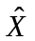, = estimate of population total X, Y for the characteristics x, y

Under the above symbols,
y_{srmidjk} = observed value of the characteristic y for the k^{th} household in the j^{th} second stage stratum of the d^{th} hg/ sb (d = 1, 2) of the i^{th} urban FSU belonging to the m^{th} sub-sample of the r^{th} panel of s^{th} stratum
y_{stmidjk} = observed value of the characteristic y for the k^{th} household in the j^{th} second stage stratum of the d^{th} hg/ sb (d = 1, 2) of the i^{th} rural FSU belonging to the m^{th} sub-sample of the t^{th} sub-stratum of s^{th} stratum

However, for ease of understanding, a few subscripts have been suppressed in following paragraphs where they are obvious.
3. Formulae for Quarterly Estimates of Aggregates for a particular stratum × panel × sub-sample of the urban sector from Schedule 10.4:

3.1 The estimate for a stratum × panel × sub-sample may be obtained as follows:
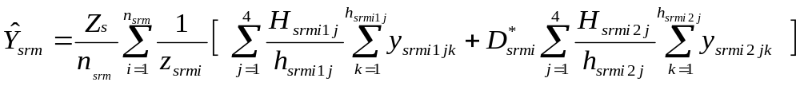

3.2 The estimate for aggregates for a particular stratum × panel based on two sub-samples may be obtained as:
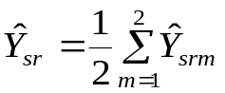

3.3 The estimate for aggregates for a particular stratum based on ‘r’ panels and two sub-samples may be obtained as:
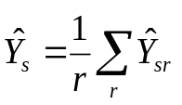, r = 1, 2, 3, 4
( r will be ‘4’ from fourth quarter and r may be less than ‘4’ till third quarter)

3.4 From fourth quarter onwards, estimate for aggregates for a particular stratum based on all the 4 panels and two sub-samples may be generated as:
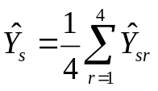

3.5 Estimate of an aggregate character for a State may be obtained by summing the stratum estimates as follows:
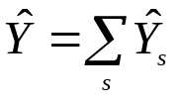
3.6 Let 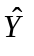 and 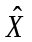 be the estimates of the aggregates Y and X for two characteristics y and x respectively at the State/ UT/ all-India level. Estimate of a ratio 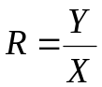 at State level may be obtained as the ratio of aggregates of two characters at State levels: 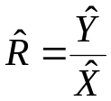
3.7 The estimates of change over the quarters will be measured by the simple difference between the estimates of aggregates or ratios of the corresponding quarters.
3.8 Estimates of Error: The estimated variances of the above estimates will be as follows:

3.8.1 For aggregate :
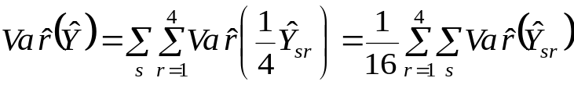 where 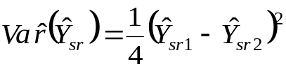, where 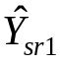 and 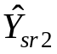 are the estimates for sub-sample 1 and sub-sample 2 respectively for stratum ‘s’ and panel ‘r’.
3.8.2 For ratio 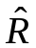:

where 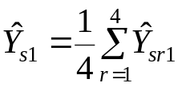 and 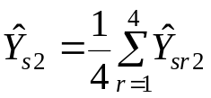;

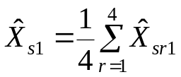 and 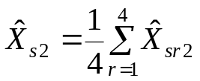

3.9 Estimates of Relative Standard Error (RSE):

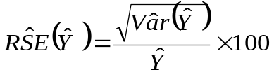

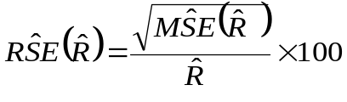

3.10 For urban samples, multipliers for panel ‘r’ will be as follows:

sch. | sector | formula for multipliers
sch. | sector | segment 1 | segment 2
10.4 | urban | 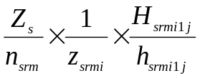 | 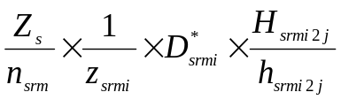
 |  | j = 1, 2, 3, 4

4. Formulae for Annual Estimates of Aggregates for a particular sub-sample and stratum × sub-stratum in the rural/urban sector from Schedule 10.4:

4.1 For rural:
4.1.1 For rural areas, annual estimates of aggregates may be obtained from the data collected in four quarters.

(i) For j^{th} second-stage stratum of a stratum × sub-stratum, for a particular sub-sample:
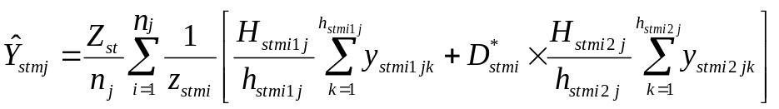

(ii) For all second-stage strata combined:
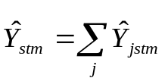
4.1.2 Estimate for aggregates for a sub-stratum:
Estimate for aggregates for a sub-stratum (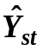) based on two sub-samples in a sub-stratum is obtained as:
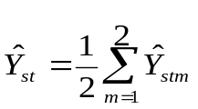

4.1.3 Estimate for aggregates for a stratum:
Estimate for a stratum (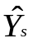) will be obtained as
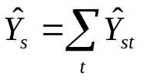

4.1.4 Estimate of Aggregates at State/UT/all-India level:
The estimate at the State/ UT/ all-India level is obtained by summing the stratum estimates 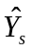over all strata belonging to the State/ UT/ all-India.

4.1.5 Estimates of Ratios:
Let and be the estimates of the aggregates Y and X for two characteristics y and x respectively at the State/ UT/ all-India level.
Then the combined ratio estimate 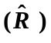of the ratio 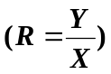 will be obtained as 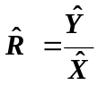

4.1.6 Estimates of Error: The estimated variances of the above estimates will be as follows:
4.1.6.1 For aggregate 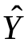:
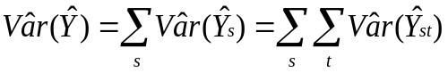 where 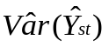 is given by
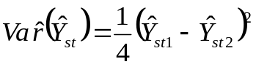, where 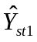 and 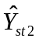 are the estimates for sub-sample 1 and sub-sample 2 respectively for stratum ‘s’ and sub-stratum ‘t’.

4.1.6.2 For ratio :

4.1.6.3 Estimates of Relative Standard Error (RSE):

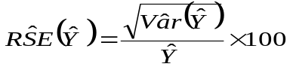
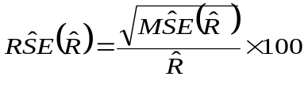

4.2 For urban:

4.2.1 Considering first visit schedules for each of the four panels of four quarters, annual estimates of aggregates for a particular sub-sample and stratum may be obtained for urban areas. For rural areas, annual estimates of aggregates may be obtained from the data collected in four quarters.

(i) For j^{th} second-stage stratum of a stratum, for a particular sub-sample:
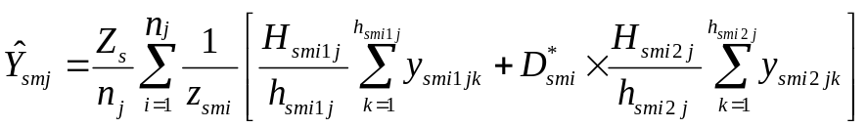

(ii) For all second-stage strata combined:
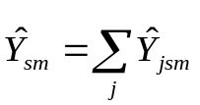
4.2.2 Estimate for Aggregates for a stratum:
Estimate for aggregates for a stratum () based on two sub-samples in a stratum is obtained as:
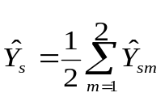

4.2.3 Estimate of Aggregates at State/UT/all-India level:
The estimate at the State/ UT/ all-India level is obtained by summing the stratum estimates over all strata belonging to the State/ UT/ all-India.

4.2.4 Estimates of Ratios:
Let and be the estimates of the aggregates Y and X for two characteristics y and x respectively at the State/ UT/ all-India level.
Then the combined ratio estimate of the ratio will be obtained as

4.2.5 Estimates of Error: The estimated variances of the above estimates will be as follows:
4.2.5.1 For aggregate :
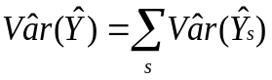 where 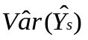 is given by
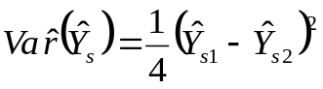, where 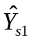 and 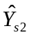 are the estimates for sub-sample 1 and sub-sample 2 respectively for stratum ‘s’.

4.2.5.2 For ratio :

4.2.5.3 Estimates of Relative Standard Error (RSE):

5. Multipliers:

The formulae for multipliers at stratum/sub-stratum/second-stage stratum level for a sub-sample are given below:

schedule | sector | formula for multipliers
schedule | sector | hg / sb 1 | hg / sb 2
10.4 | rural | 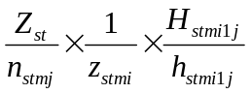 | 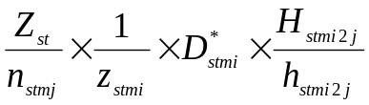
10.4 | j = 1, 2, 3 for rural
10.4 | urban | 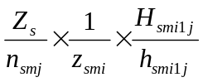 |  | 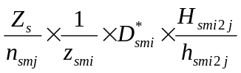
10.4 | j = 1, 2, 3, 4 for urban

Note:
- For estimating any characteristic for any domain not specifically considered in sample design, indicator variable may be used.
- Multipliers have to be computed on the basis of information available in the listing schedule irrespective of any misclassification observed between the listing schedule and detailed enquiry schedule.

6. Treatment for zero cases, casualty cases etc.:

6.1 While counting the number of FSUs surveyed (n_{sm} or n_{stm}) in a stratum/sub-stratum, all the FSUs with survey codes 1 to 6 in Schedule 0.0PL will be considered. In addition, if no SSU is available in the frame for Schedule 10.4, then also that FSU will be treated as surveyed in respect of that schedule. However, if SSUs are available in the frame of the FSU but none of these could be surveyed then that FSU has to be treated as casualty and it will not be treated as surveyed in respect of Schedule 10.4.

6.2 Casualty cases: FSUs with survey code 7 as per Schedule 0.0PL are treated as casualties. In addition to this, an FSU, although surveyed, may have to be treated as casualty for Schedule 10.4 and a particular second stage stratum as given in the following para:

6.2.1 FSUs with survey codes 1 or 4 as per Schedule 0.0PL having number of households in the frame of j^{th} second stage stratum greater than 0 but number of households surveyed according to data file, considering both hg/sb together, as nil (i.e. H_{i1j} + H_{i2j} >0 but h_{i1j} + h_{i2j} =0) will be taken as casualties for j^{th} second stage stratum.

All the FSUs with survey codes 1 to 6 as per Schedule 0.0PL minus the number of casualties as identified above will be taken as the number of surveyed FSUs (n_{stmj} ) for that (stratum/sub-stratum) ×( second stage stratum).

When casualty for j^{th} second stage stratum occurs for a particular hg/sb but not for the other hg/sb, the FSU will not be treated as casualty but some adjustments in the value of H for the other hg/sb will be done as follows:

- Suppose for hg/sb 1, H_{i1j} > 0 but h_{i1j} = 0 while for hg/sb 2, H_{i2j} > 0 and h_{i2j} > 0. In that case 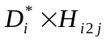 will be replaced by 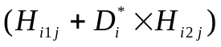 in the formula for multiplier of hg/sb 2.

(ii) Suppose for hg/sb 1, H_{i1j}>0 and h_{i1j} > 0 while for hg/sb 2, H_{i2j}>0 but h_{i2j}=0. In that case 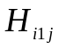will be replaced by in the formula for multiplier of hg/sb 1.

It may be noted that n_{smj} or n_{stmj} would be same for segment 1 & 2 of an FSU.

7. Treatment in cases of void second-stage strata/sub-strata /strata at FSU or household level:

7.1 A stratum/sub-stratum may be void because of the casualty of all the FSUs belonging to the stratum/sub-stratum. This may occur in one sub-sample or in both the sub-samples. If it relates to only one sub-sample, then estimate for the void stratum/sub-stratum may be replaced with the estimate as obtained from the other sub-sample for the same stratum/sub-stratum.

7.2 When a stratum/sub-stratum is void in both the sub-samples, the following procedure is recommended:
Case (I): Stratum/Sub-stratum void cases at FSU levels (i.e. all FSUs having survey code 7):
- If a rural/urban sub-stratum is void then it may be merged with the other sub-stratum of the stratum.
- If a rural/urban stratum is void due to all FSUs being casualty, it may be excluded from the coverage of the survey. The state level estimates will be based on the estimates of districts for which estimates are available and remarks to that effect may be added in appropriate places.

Case (II): Stratum/Sub-stratum void case at second stage stratum level (i.e. all the FSUs were casualties for a particular second stage stratum):

An FSU may be a casualty for a particular second stage stratum although survey code was not 7. If all the FSUs of a stratum/sub-stratum become casualties in this manner for a particular second stage stratum, the stratum/sub-stratum will become void. In such cases, the void second stage stratum will be merged with the nearby second stage stratum within the FSU.

8. Reference to the values of Z_{st}, n_{s,} z_{sti}, D_{sti}, D*_{sti}, D_{si}, D*_{si}, H_{sti1j}, h_{sti1j}, H_{sti2j}, h_{sti2j:}

- Values of Z_{st} and the number of FSUs allotted for the whole round are given in Appendix Table 2 for rural sector and in Appendix Table 3 for urban sector.
- Surveyed number of FSUs (n_{st}) should not be taken from the tables. The value of n_{stm} for each sub-sample is to be obtained following the guidelines given in para 6 above. It includes uninhibited and zero cases but excludes casualty cases.
- The value of z_{sti} for the samples selected by PPS is to be taken from the column of sample list under the heading ‘frame population’ for rural samples and ‘block size’ i.e. total number of households in each UFS block for urban samples.
- Value of D_{sti} is to be taken from item 14 of Block 1, Schedule 0.0PL. D*_{sti} is to be calculated from the value of D_{sti} .
- Values of H_{sti1j}, H_{sti2j} are to be taken from column (5), Block 6 of Schedule 0.0PL for respective segment and second-stage stratum.
- The value of h_{sti1j} and h_{sti2j} should not be taken from column (9), Block 6 of Schedule 0.0PL. The figures should be obtained by counting the number of households available in the data file excluding the casualty households.

Table 1: allocation of sample villages and blocks for PLFS
State/UT | number of sample villages/blocks
State/UT | total | rural | urban
(1) | (2) | (3) | (4)
ANDHRA PRADESH | 496 | 272 | 224
ARUNACHAL PRADESH | 216 | 136 | 80
ASSAM | 440 | 328 | 112
BIHAR | 568 | 400 | 168
CHHATTISGARH | 280 | 176 | 104
GOA | 56 | 24 | 32
GUJARAT | 440 | 208 | 232
HARYANA | 328 | 168 | 160
HIMACHAL PRADESH | 256 | 208 | 48
JAMMU & KASHMIR | 424 | 240 | 184
JHARKHAND | 344 | 208 | 136
KARNATAKA | 520 | 224 | 296
KERALA | 568 | 264 | 304
MADHYA PRADESH | 584 | 336 | 248
MAHARASHTRA | 1008 | 448 | 560
MANIPUR | 320 | 160 | 160
MEGHALAYA | 160 | 104 | 56
MIZORAM | 192 | 64 | 128
NAGALAND | 128 | 72 | 56
ODISHA | 496 | 360 | 136
PUNJAB | 400 | 192 | 208
RAJASTHAN | 528 | 312 | 216
SIKKIM | 96 | 56 | 40
TAMIL NADU | 832 | 392 | 440
TELANGANA | 360 | 160 | 200
TRIPURA | 232 | 152 | 80
UTTAR PRADESH | 1136 | 728 | 408
UTTARAKHAND | 216 | 120 | 96
WEST BENGAL | 800 | 424 | 376
A & N ISLANDS | 64 | 32 | 32
CHANDIGARH | 48 | 8 | 40
D & N HAVELI | 24 | 8 | 16
DAMAN & DIU | 16 | 8 | 8
DELHI | 128 | 8 | 120
LAKSHADWEEP | 24 | 8 | 16
PUDUCHERRY | 72 | 16 | 56
ALL- INDIA | 12800 | 7024 | 5776

